# SPRINT 3

|  |  |
| --- | --- |
| TEAMID | PNT2022TMID01063 |
| PROJECT NAME | SIGNS WITH SMART CONNECTIVITY FOR BETTER ROAD SAFETY |

Creating link for MIT app inventor and get the output on that link

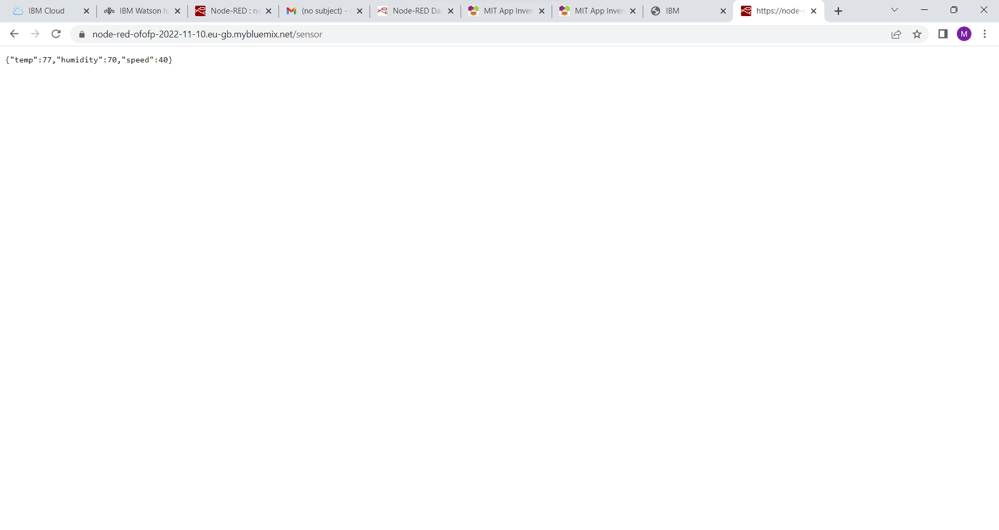

Creation of front end on MIT app inventor

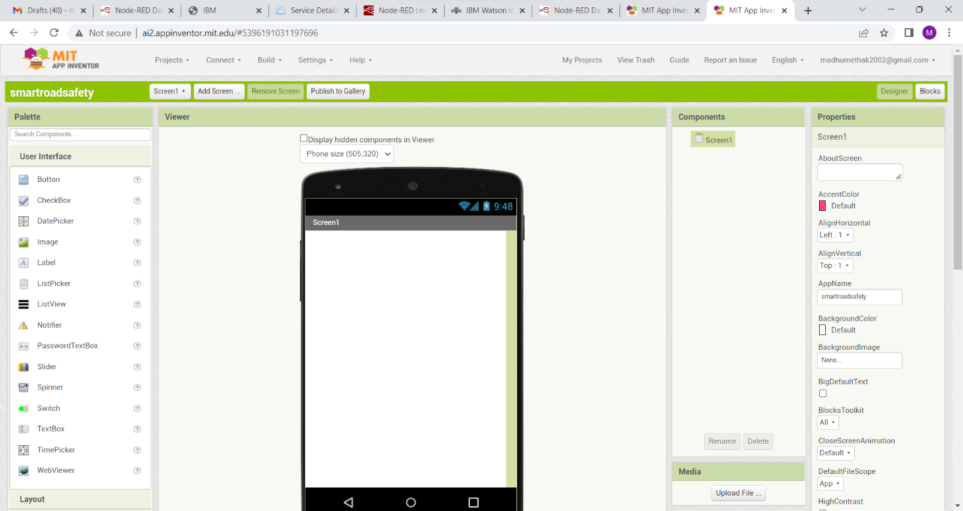

The components are in progress and completed and released in sprint 4

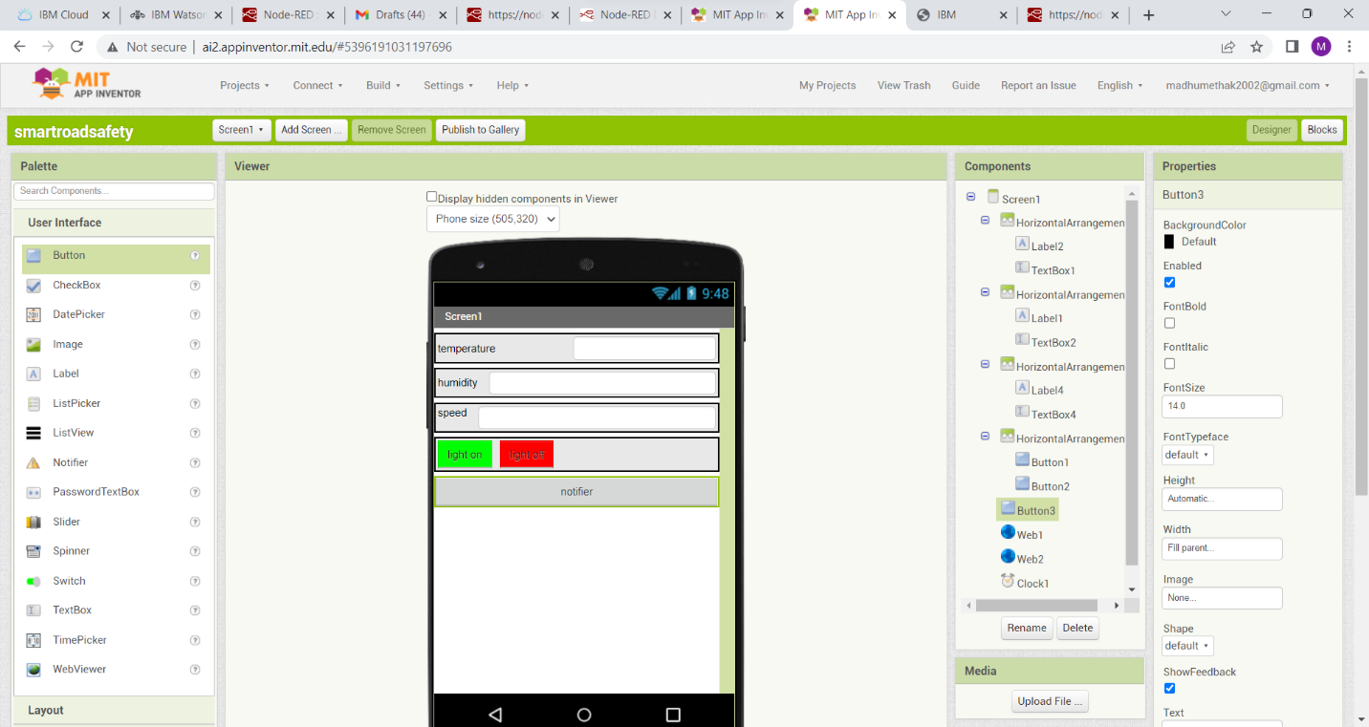

Connecting the node red link with the MIT app inventor and the complete process will be released in sprint 4

